University of Iowa Graduate and Professional Student Government
General Assembly Meeting Minutes
Date: [03-25-2025]
Location: Iowa Memorial Union, Room [337]
Meeting Called to Order: [7:00 PM]

Attendance:

Ian Patterson
Austin Olberding
David
Travis Fischer
John Stevenson
Sabrina Renner
Allison Darling
Khyathi Gadag
Kshitija Kale
Ganrong Fu
Kyleakin Helm-Kwasny
Bethany Walczak
Emily Killian
Nathan Chen
Katy volz
Stephanie Pedersen
Josie Welker
Airiana Mohr
Jennah Johnson
Patrick Johnson
James Miller

Executives:
- President: Khyathi Gadag
- Vice President: Abigail Crabtree
- Cabinet Director: Airiana Mohr
- Finance Director: Patrick Johnson
- Physical Health and Safety Director: Austin Olberding
- International Affairs Director: Krishna Venkatapur
- Government Relations Director: James Miller
- Mental Health Director: Bethany Walczak
- Communications Director: Ganrong "James" Fu
- Grants Director: Nanle Gusen
- Interprofessional Director: Brigitte Ledferd
- DEI Director: Lara Zeng
- Sustainability Director: Josie Welker
Delegates:
- Association of Graduate Nursing Students (AGNS):
  - David Mares-Davila
  - Sam Bjornson
- Carver College of Medicine Student Government (CCOMSG):
  - Jennah Johnson
  - Innes Hicsasmaz
- College of Pharmacy Student Leadership Council (COPSLC):
  - Ian Patterson
  - Sabrina Renner
- College of Public Health Graduate Student Association (CPHGSA):
  - Emily Killian
  - Allison Darling
- Graduate Student Senate (GSS):
  - Fine Arts & Humanities: Mansour Golpour
  - Physical Science, Math, Engineering: John Stevenson
  - Social Science & Education: Mavis Gyesi
  - Biology and Medicine: Kshitija Kale
  - At-Large 1: Kyleakin Helm-Kwasny
  - At-Large 2: Travis Fischer
- Iowa American Student Dental Association (IASDA):
  - Vi Phan
  - Sam Allen
  - Anna Hedges
  - Kathryn Volz
- Iowa Student Bar Association (ISBA):
  - Adam Kahn

Executive Core Elections
  - President
    - Abby Crabtree
      - Cover Letter
      - Resume
    - Patrick Johnson
      - Cover Letter
      - Resume
    - 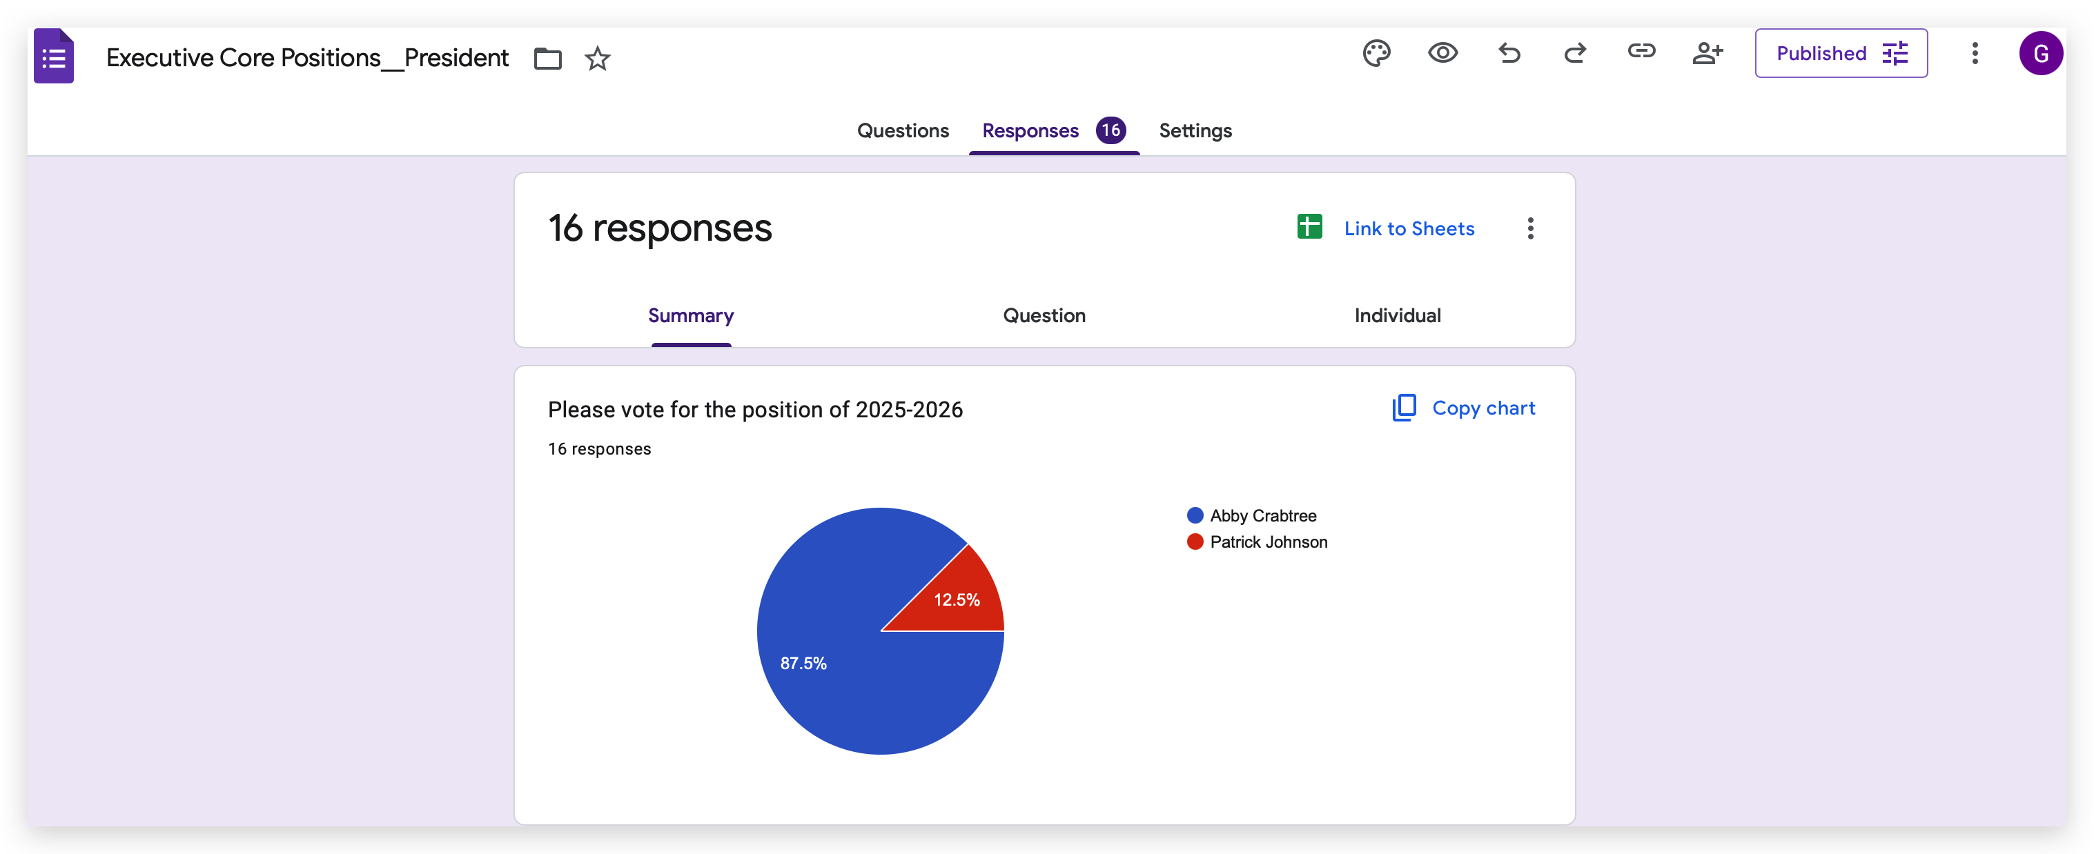
  - Vice President
    - Airiana Mohr
      - Cover Letter
      - Resume
    - Nanle Gusen
      - Cover Letter
      - CV
      - 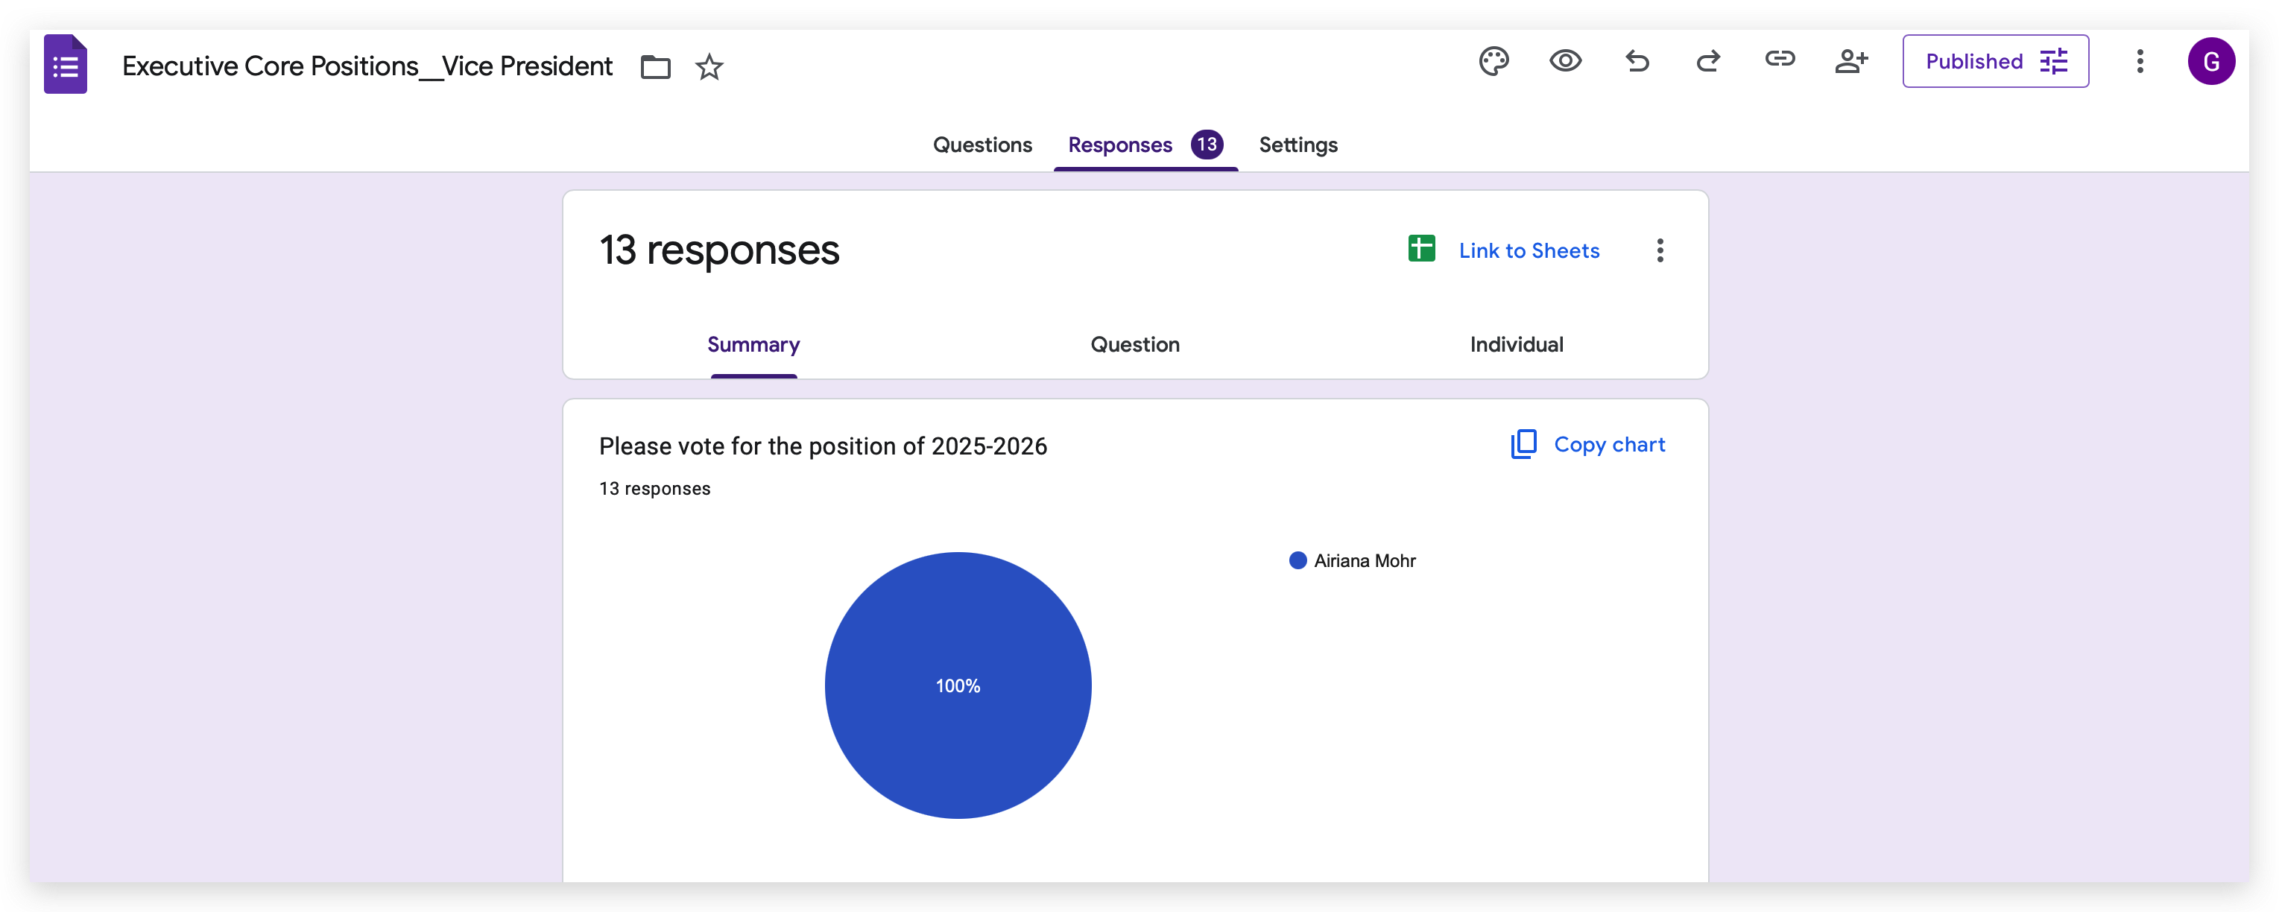
  - Cabinet Director (moved to future meeting)
    - Airiana Mohr
      - Cover Letter (see above)
      - Resume (see above)

    - Nanle Gusen
      - Cover Letter (see above)
      - CV (see above)
  - Finance Director
    - Patrick Johnson
      - Cover Letter (see above)
      - Resume (see above)
      - 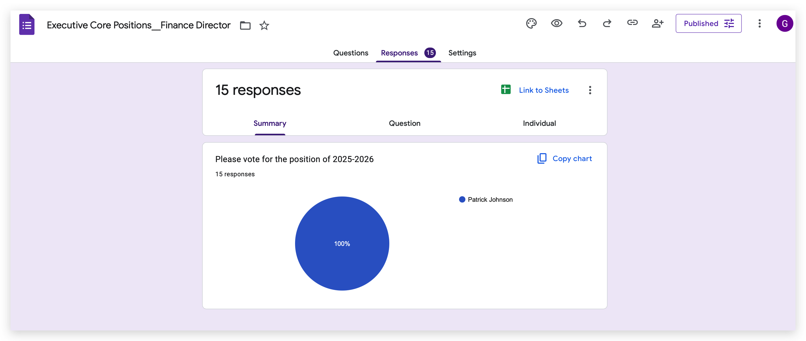

Reports of Officers and Standing Committees
- President (Khyathi Gadag):
AOD offices are closed

- Vice President (Abigail Crabtree):
meeting with delegates for end of year wrap up
Transition documents for delegates

- Finance Director (Patrick Johnson):
Student activity fee finalized

- Cabinet Director: Airiana Mohr
GPSG ball
Director positions are still open

- GPAC Director - Nathan Chen
  - GPAC Funding Tenet changes for FY2026 made and updated online
  - GPAC Funding Request form updated by SOBO
  - GPSG Funding Cycle 1 for FY2026 is currently active, closes 4/11/25
  - GPAC currently has $3000 in rapid funding for the rest of the semester, made available by GPSG

- Grants Director - Nanle Gusen

- Communications Director - Ganrong "James" Fu
Social media posts
Mass email reminder on executive and cabinets position for 2025-2026
Making summer transition documents

- Diversity, Equity, and Inclusion Director - Lara Zeng

- Governmental Relations Director - James Miller

- International Affairs Director - Krishna Venkatapur

- Interprofessional Director - Brigitte Ledferd

- Mental Health Director - Bethany Walczak

- Physical Health and Safety Director - Austin Olberding
  - Dismantling Rape Culture – Online Educational (Today 4-5:15)
  - Certified Peer Educator Legislation
  - Free CPR/AED Training – Apr 13, 1-3 and Apr 22, 5-7
  - Sexual Assault Awareness Month programming
    - Take Back the Night – April 22nd
    - Clothesline Project – April 2nd, April 9th 5:30-7:30 at WRAC
    - Various other DVIP events – expect a story on Instagram
- Sustainability Director - Josie Welker
  - Save Soil movie event, showing “Common Ground” a film about soil regeneration: March 29 2:00 – 3:00 pm at the Iowa Theater. Snacks will be provided. Open to anyone in the Iowa City community please advertise to your member governments. Can RSVP here but not required:
  - https://www.eventbrite.com/e/save-soil-movie-event-cultivating-change-iowa-tickets-1259005241569?utm_experiment=test_share_listing&aff=ebdsshios
  - Sustainability lecture event titled "Our Water, Our Community" which will have speakers Dr. Eric Gidal, Dr. Dave Cwiertny, Dr. Chris Jones, and Dr. Larry Weber discuss different aspects of ongoing water quality topics in the state of Iowa. Thursday, April 24 from 2:00 – 4:15 pm in UCC 2520D
  - Collaborations with Environmental Coalition and Undergraduate Student Government upcoming for earth month in April, keep up with the office of sustainability and environment and our GPSG socials for more information.
  - Thank you all for a great year! I hope you have a great rest of your semester :)

Reports of Delegates
- Association of Graduate Nursing Students (AGNS):
no updates

- Carver College of Medicine Student Government (CCOMSG):
match day

- College of Pharmacy Student Leadership Council (COPSLC):

- College of Public Health Graduate Student Association (CPHGSA):
DEI events

- Graduate Student Senate (GSS):
Research conference Saturday night
Grants closing soon
Student night and weekend parking

- Iowa American Student Dental Association (IASDA):
nine students to DC for National Lobby Day

- Iowa Student Bar Association (ISBA):
ISBA election

Old Business:

New Business:

- Legislation Title:
  - D.B.11 2025-26 Women’s Resource and Action Center CPE Funding
    - Passed
  - D.B.12 2025 GPSG CoBRA Update
    - Passed
  - D.B.13-16

