**University of Iowa Graduate and Professional Student Government**

**General Assembly Meeting Minutes**  
**Date:** [04-22-2024]  
**Location:** Iowa Memorial Union, Room [337]  
**Meeting Called to Order:** [7:00 PM]

**Attendance:**

**Adam Kahn**

**Brigitte Ledferd**

**Bethany Walczak**

**Nanle Gusen**

**Jennah Johnson**

**Emily Killian**

**Austin Olberding**

**David Mares**

**James R Miller**

**Innes Hicsasmaz**

**James Fu**

**Ian Patterson**

**Khyathi Gadag**

**Travis Fischer**

**Josie Welker**

**Brynn Kyleakin Helm-Kwasny**

**Nathan Chen**

**Airiana Mohr**

**Allison Darling**

**John Stevenson**

**Kshitija Kale**

**Stephanie Pedersen**

**Anna Hedges**

**Executives:**

* **President:** Khyathi Gadag
* **Vice President:** Abigail Crabtree
* **Cabinet Director:** Airiana Mohr
* **Finance Director:** Patrick Johnson
* **Physical Health and Safety Director:** Austin Olberding
* **International Affairs Director:** Krishna Venkatapur
* **Government Relations Director:** James Miller
* **Mental Health Director:** Bethany Walczak
* **Communications Director:** Ganrong "James" Fu
* **Grants Director:** Nanle Gusen
* **Interprofessional Director:** Brigitte Ledferd
* **DEI Director:** Lara Zeng
* **Sustainability Director:** Josie Welker

**Delegates:**

* **Association of Graduate Nursing Students (AGNS):**
  + **David Mares-Davila**
  + **Sam Bjornsonx**
* **Carver College of Medicine Student Government (CCOMSG):**
  + **Jennah Johnson**
  + **Innes Hicsasmaz**
* **College of Pharmacy Student Leadership Council (COPSLC):**
  + **Ian Patterson**
  + **Sabrina Renner**
* **College of Public Health Graduate Student Association (CPHGSA):**
  + **Emily Killian**
  + **Allison Darling**
* **Graduate Student Senate (GSS):**
  + **Fine Arts & Humanities: Mansour Golpour**
  + **Physical Science, Math, Engineering: John Stevenson**
  + **Social Science & Education: Mavis Gyesi**
  + **Biology and Medicine: Kshitija Kale**
  + **At-Large 1: Kyleakin Helm-Kwasny**
  + **At-Large 2: Travis Fischer**
* **Iowa American Student Dental Association (IASDA):**
  + **Vi Phan**
  + **Sam Allen**
  + **Anna Hedges**
  + **Kathryn Volz**
* **Iowa Student Bar Association (ISBA):**
  + **Adam Kahn**

**Reports of Officers and Standing Committees**

* **President** – Khyathi Gadag
* Upcoming board of regents meeting this Thursday – we will continue advocating for embedded counseling, and will be introducing the new leadership to the board
* Currently, the shared governance is working on preparing a streamlined document (how to deliberate and what kind of questions to be asked) for future use when interviewing Deans and other senior leadership searches
* Had the last meeting with the office of president last week!
* Looking forward to seeing you all at the GPSG inauguration this Saturday – please do come as your time permits it is the one last time our AC group will come together as a team😊
* THANK YOU everyone for being such an amazing group to work with! I’m truly grateful to get a team like this.
* **Vice President** – Abby Crabtree
* **Cabinet Director** – Airiana Mohr
* The inaugural GPSG Ball was hosted on April 19. We had about 40 students in attendance, which is great for the first year! Brigitte, Abby, Patrick, James, and I identified a few clear steps for moving forward next year with making the event bigger.
* I am hosting EoY 1:1’s with directors this week and next week. We’re discussing transition responsibilities and remaining initiatives.
* Outgoing directors will be connected with incoming directors tomorrow via email (by me) and will be required to do a transition meeting before the end of the academic year.
* Inauguration is this weekend (Sat. April 26, 3-5) and is highly encouraged for all outgoing and incoming members to attend. We will be recognizing outgoing directors, handing out the GPSG awards, and recognizing the incoming administration. I worked with USG’s VP, USG Speaker, and Bill to finalize the script today.
* The IMU renovations will be up for vote at the Board of Regents meeting on Thursday. Khyathi, Abby, James, and I will be attending and advocating for this to pass as well as the points Khyathi mentioned above.
* **Finance Director** – Patrick Johnson
* **GPAC Director -** Nathan Chen
* **Grants Director -** Nanle Gusen
* **Communications Director -** Ganrong "James" Fu
  + Updating websites for meeting minutes
  + Mass email requests
  + Transition documents

* **Diversity, Equity, and Inclusion Director** - Lara Zeng
* **Governmental Relations Director -** James Miller
* **International Affairs Director -** Krishna Venkatapur
* **Interprofessional Director -** Brigitte Ledferd
* **Mental Health Director -** Bethany Walczak
* **Physical Health and Safety Director -** Austin Olberding
* **Sustainability Director -** Josie Welker
  + Please join the sustainability committee for our water quality lecture event on Thursday, Our Water Our Community form 2-4 pm in the UCC room 2520D
  + We have plans in place for an Ewaste event at the end of the semester – stay tuned!

**Reports of Delegates**

Delegate Updates:

* Association of Graduate Nursing Students (AGNS)
  + Filled every position on the AGNS board!
    - New GPSG representatives are Alexandra Siskovic and Braxton Pinske
* Carver College of Medicine Student Government (CCOMSG)
  + Elections for our government is ongoing! (Almost done!)
  + All grad/professional school party hosted by AKK part 2!! Friday, May 9th at 8pm - 339 Teeters Ct Iowa City - $5 at the door to get drinks! (bring ID)
* College of Pharmacy Student Leadership Council (COPSLC)
* College of Public Health Graduate Student Association (CPHGSA)
* Graduate Student Senate (GSS)
  + GSS has elected their 2025-2026 Executive Committee!
    - 2025-2026 GPSG delegates: Rachel Valentine (Social and Educational Sciences), Kshitija Kale (Biological and Medical Sciences; GSS Social Media Director), Brendan Powers (Physical, Mathematical, and Engineering Sciences), Travis Fischer (At-large #1; GSS President), John Stevenson (At-large #1; GSS Vice President), Fine Arts & Humanities delegate TBD
  + Friday Night Vibes event on April 11th had over 204 attendees! This surpassed our expectations and was a lot of fun!
  + Jakobsen Research Conference was held on May 29th. We are hoping to advertise earlier in the academic year to recruit more participants in the future.
  + GSS is drafting a letter about our support for the formation of a Big 10 mutual defense compact to protect students’ freedom of protest without retaliation
  + [GSS letter regarding Parking and Transportation concerns is linked here](https://iowa.sharepoint.com/:w:/s/GraduateandProfessionalStudentGovernment/ERHraoohh05Mvc2GjPNwe5wBBEqhradr-jDe3BGmQN49aA)
    - We would like the support of GPSG to elevate this to administrators
  + Kyleakin’s personal project: Currently working with some Grad College administrators to make student support (especially disability accommodations and resources) more visible to students, faculty, and staff. If you have any thoughts about accommodations that would be beneficial grad college-wide, please reach out to me!
* Iowa American Student Dental Association (IASDA)
  + National Lobby Day was a success!! We lobbied for 3 different bills and the messages seemed to be well received from everyone we met with 😊
  + In the process of taking applications for our E-board currently and then elections will begin next week with winners being announced at our Frolics on May 3rd.
  + The following week we will be taking applications for all of our chair positions with elections to follow.
  + Friday, May 3rd we will be hosting a talent show at Coralville Center for Performing Arts @7pm. Free to attend!
  + Friday May 9th from 7:30-9:30pm we are having a dodgeball tournament as a pre-dental/dental collaboration. It will be at the Fieldhouse South Gym Courts.
* Iowa Student Bar Association (ISBA)

**Elections:**

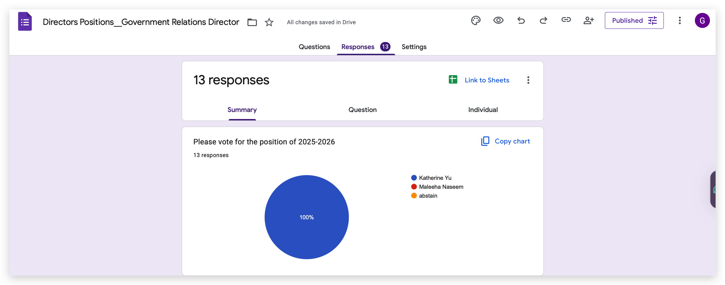

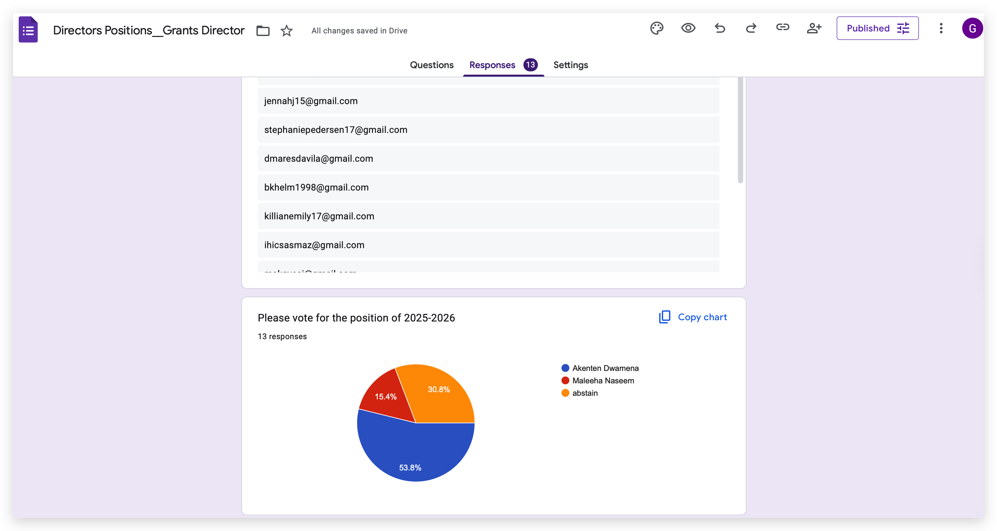

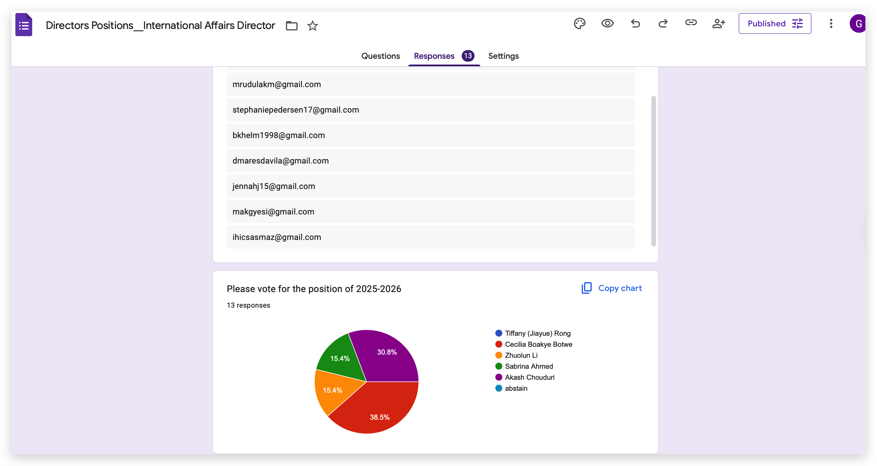

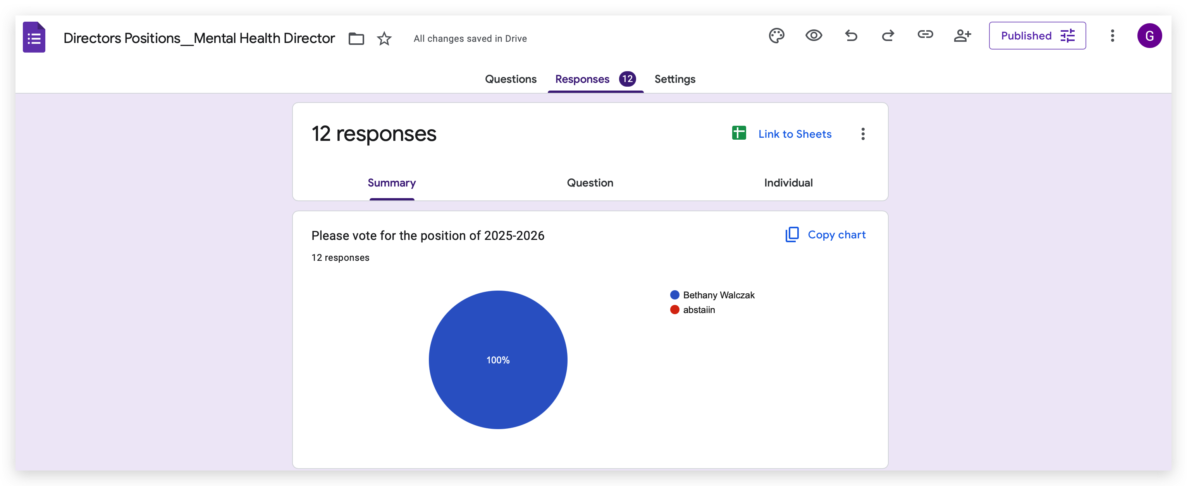

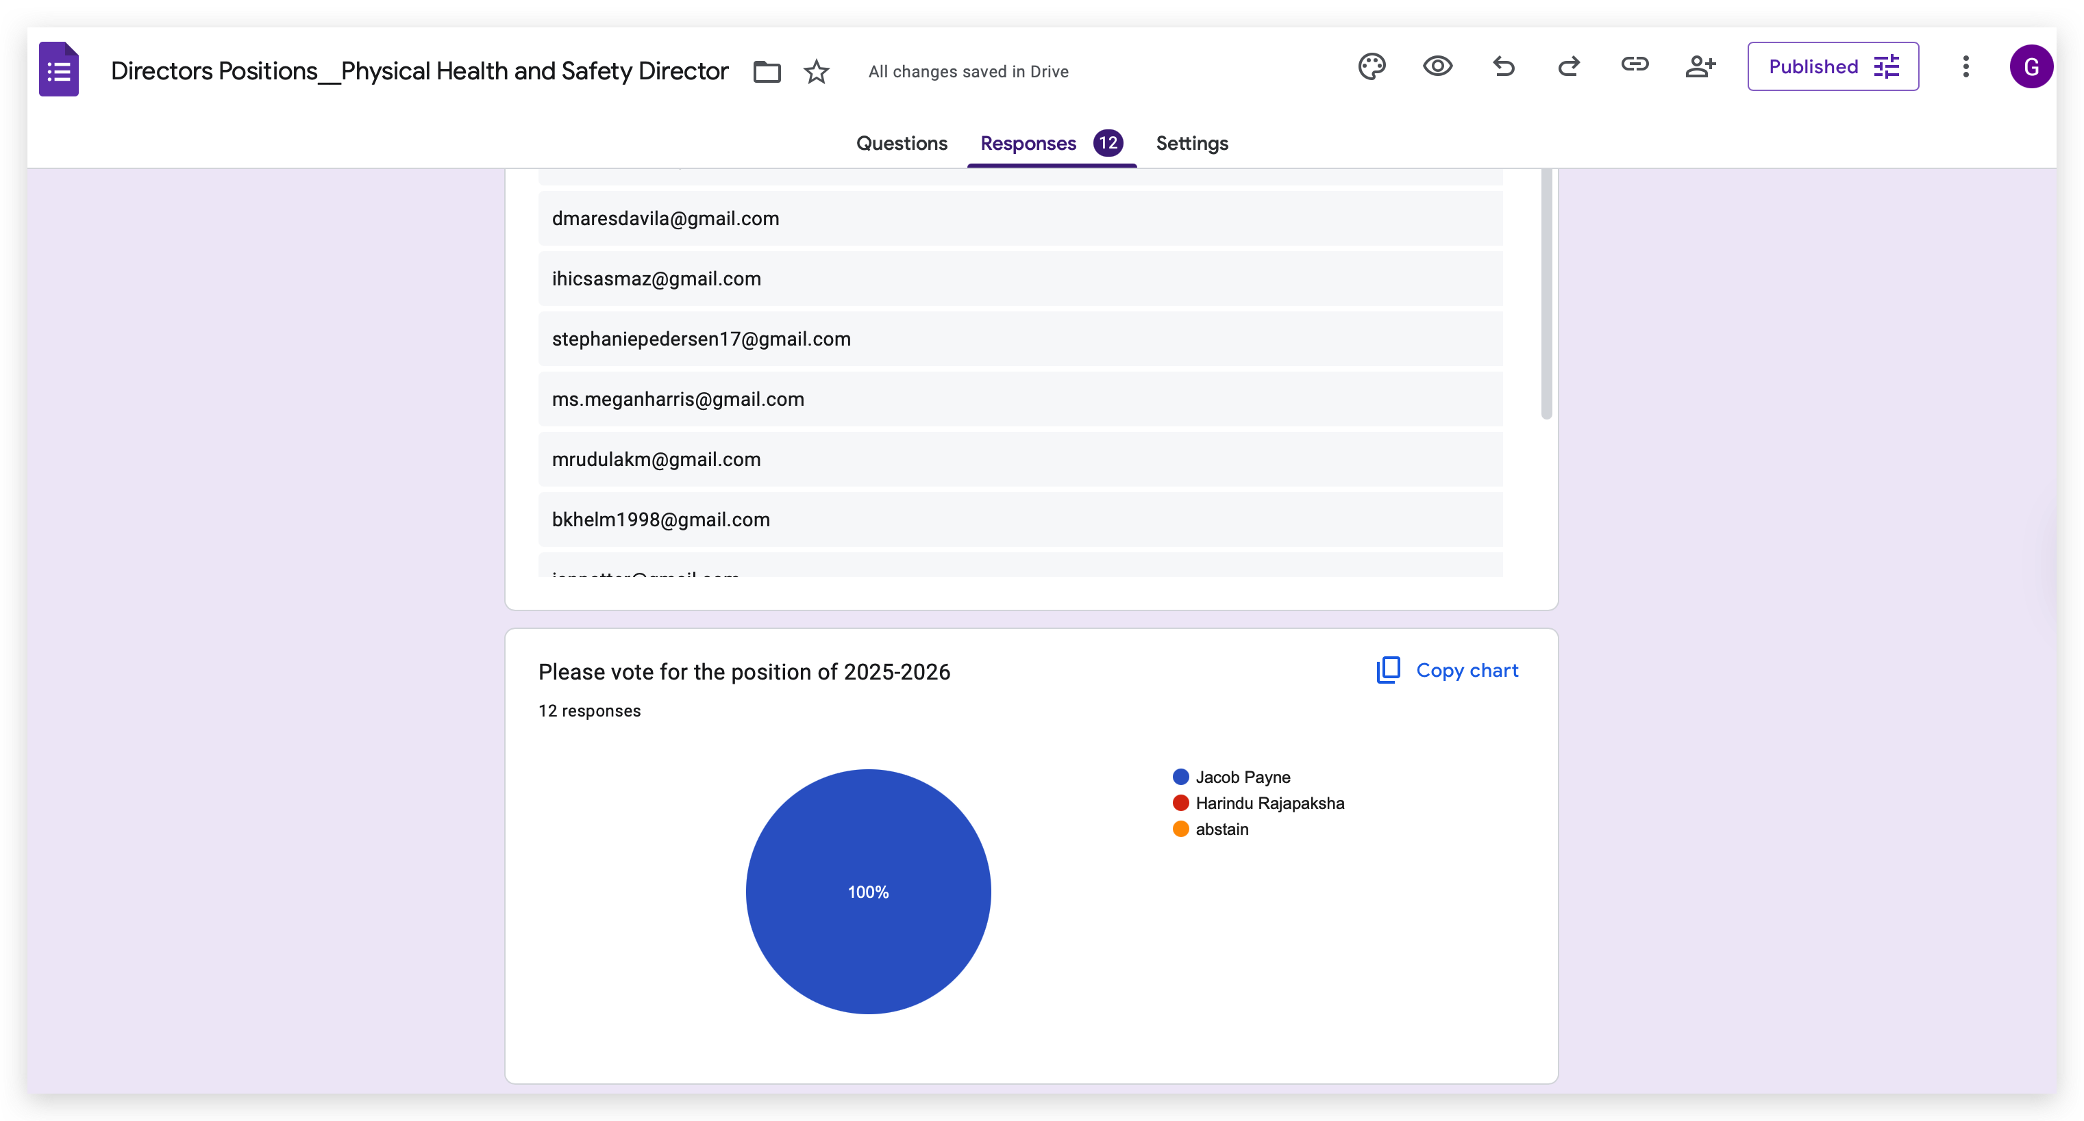

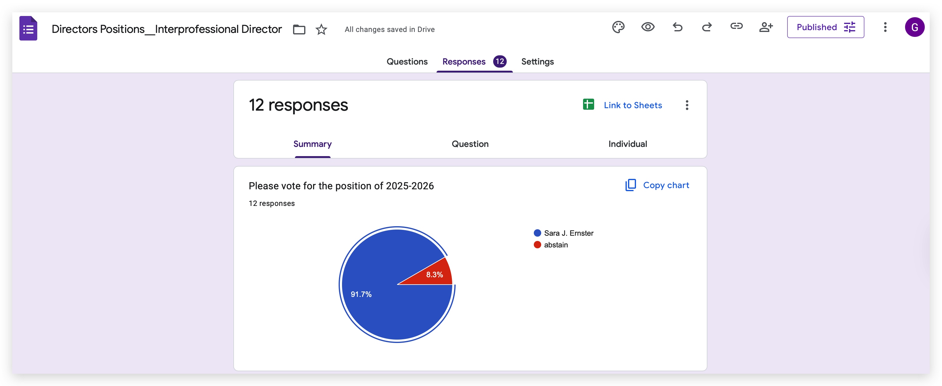

**Old Business:**

**New Business:**

* **Legislation Title:**